Production Possibility Curve (PPC)
AKA the Production Possibility Frontier

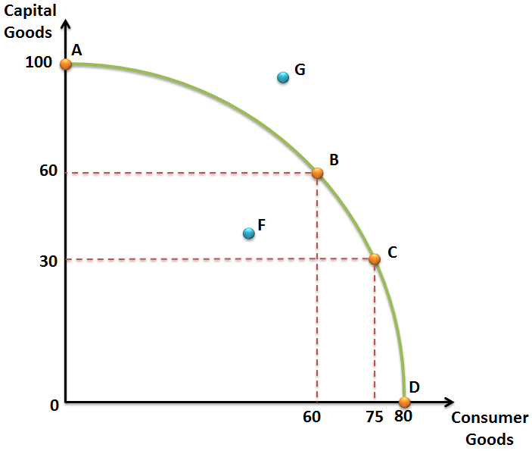

Based on PPC, answer the following questions:
1. What points on the curve are efficient?

2. What point can’t be produced, because there is not enough resources?

3. What is the opportunity cost of moving from point A to B? B to C?

4. What point on the PPC is possible but inefficient?

5. What does a shift to the right in the curve represent? What does a shift to the left represent?

