Name:__________________________________Block:__________Date:________
Unit 2: Microeconomics
Microeconomics: is the area of economics that deals with behavior and decision making by ___________, such as individuals and businesses.

Examples include looking at individual businesses, a particular industry or how prices are established.

Circular Flow Model: a model that illustrates the flow of __________________ (buying and selling) between households and firms.

Market: is a ____________ or ______________ that allows buyers and sellers to exchange goods and services. Markets can be local, regional or global in scope.

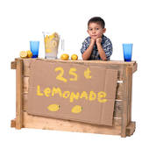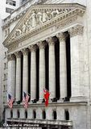

- Product market: a market where firms supply or sell goods and services to consumers. Firms __________ goods and services while households ___________ or buy goods and services.

- Resource/Factor Market: a market where resources are bought and sold. Households _________ or sell their resources to firms while firms ___________ or buy resources from the households.

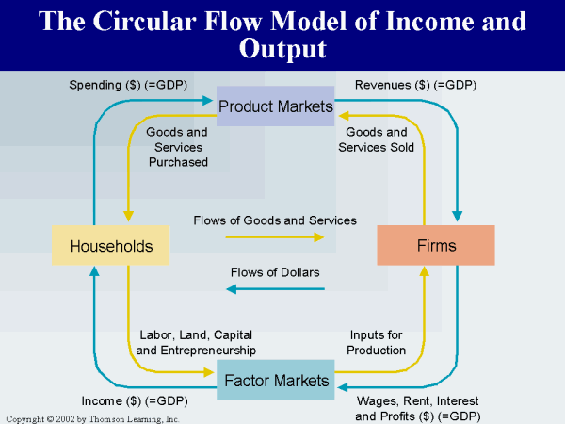

When households sell resources to businesses they receive income in return.

Land-- __________________

Labor-- _____________________

Capital-- _________________

Entrepreneur-- _______________

All the buying and selling that take place in the circular flow model requires ________ to help facilitate exchange.

Barter: a ___________________ that relies on trading goods for goods or goods for services. This is not very efficient.

There are 3 main functions of money.

- Medium of Exchange: something accepted by all parties as payment for goods and services. This is the most basic function, money must be acceptable.

- Measure of Value: a common denominator or standard that can be used to express worth in terms that most people can understand.

- Store of Value: allows purchasing power to be saved until needed in the future.

Commodity Money: money that has an __________________ as an economic good or commodity.

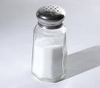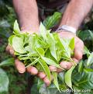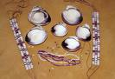

Fiat Money: Money by government decree. The money we carry is fiat money.

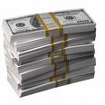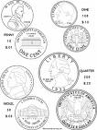
Specie: money in the form of coins made from silver or gold.

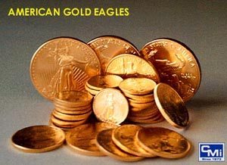

Additional characteristics of money include

- ______________

- ______________

- ______________

- _________________

Demand: is the ________ and ___________ of consumers to buy a good or service.

Desire without ability does not constitute demand.

Porshe: I have the desire but not the ability to buy one.
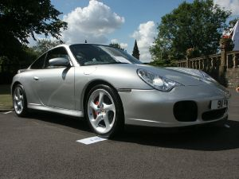

McDonalds Happy Meal: I have the ability but not the desire.

Demand Schedule: is a table or schedule that shows the various quantities demanded by consumers, of a good or service, at all prices that might prevail in the market at a point in time.

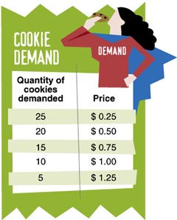

Demand Curve: is the graphical picture of the demand schedule. It contains the same information but in a different format.

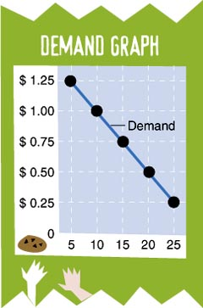

Law of Demand: states that the quantity demanded of a good or service varies _____________ with its price.

Inverse means ______________.

When price goes ___ the quantity demanded goes _________.

When price goes __________ the quantity demanded goes ___.

Change in Quantity Demanded: this is a __________________ the demand curve and shows a change in the quantity purchased in response to a change in price. This is simply a restatement of the law of demand.
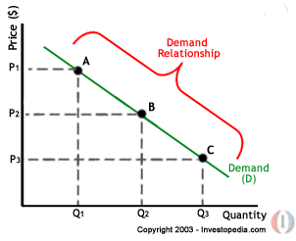

Change in Demand: occurs when people are now willing to buy different amounts of a product at the same prices as before. This is shown as a _________________, not a movement along the curve.
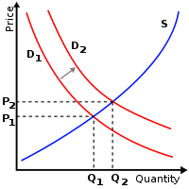

An increase in demand is a __________________.

A decrease in demand is a __________________.

There are 6 factors that can shift the demand curve to the right or left. These factors have nothing to do with the price of the product.

- Consumer Income: An ____________ in income allows consumers to buy _______ of most goods and services, so the curve will shift to the ________. A ___________ in income would cause a ___________ in demand and therefore a _____________ shift of the curve.

- Tastes & Preferences: this reflects our likes and dislikes. Advertising, news reports, fashion trends, fads, seasonal changes as well as other things can affect our tastes.

- Substitutes: are products that can be used _______________ other products. When the price of 1 good goes ___, the demand for the substitute will also go ___, and vice versa.

Examples include coke vs. pepsi or coffee vs. tea.

- Complements: are products that are _______________. When the price of 1 good goes ___, the demand for the complement will go _______, and vice versa.

Examples include milk & cereal, cameras & film or peanut butter & jelly.

- Change in Expectations: demand may change because of the expectation of some _____________. If I expect prices to rise in a few weeks, I might buy more now. If I think I might lose my job soon, I’ll begin to spend less now.

- Number of Buyers: more buyers in the market will lead to an increase in demand. Fewer buyers will lead to a decrease in demand.

Here are some factors that might affect the number of buyers.
- Population changes
- Immigration trends
- Medical advancements
- Trade agreements like NAFTA

Demand Elasticity: the extent to which a change in price causes a change in the quantity demanded.

Elasticity = _________________

In essence we want to know ____________ the quantity changes in response to a change in price.

There are 3 ranges of elasticity.

- Elastic Demand: when a given change in price causes a _________________ change in the quantity demanded.

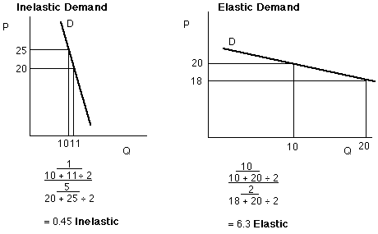

- Inelastic Demand: when a given change in price causes a _________________change in the quantity demanded.

- Unit Elastic Demand: when a given change in price causes a ______________ change in the quantity demanded.
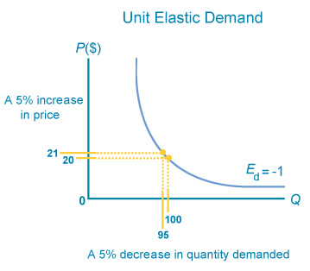

There are also 3 general questions you can ask to get a sense of whether the demand is elastic or inelastic.

- Can the purchase be delayed or postponed?
Yes--__________
No-- __________ Fresh vegetables or insulin

- Are adequate substitutes available?
Yes--___________
No-- ___________ Gasoline or butter

- Does the purchase use a large portion of income?
yes--___________
no-- ___________ a new car or plastic bags

The other side of demand is supply. This represents producers or firms that use resources to make goods and services which are then sold to households. Producers attempt to __________________ by selling what consumers want and by producing as efficiently as possible.

Supply: the amount of a product that firms are willing to offer for sale at all possible prices that might prevail in the market.

Supply Schedule: a table or schedule that shows the various quantities supplied of a product at all prices that might prevail in the market at a given time.

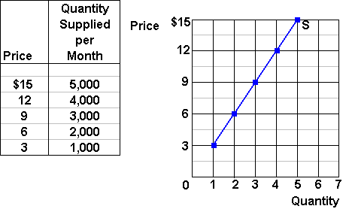

Supply Curve: the graphical representation of the supply schedule. It contains the same information as the schedule but in a different format.

Law of Supply: states that the price and the quantity supplied are __________ related to each other.
Direct means that both variables _________________. As price increases, so does quantity supplied. As price decreases, so does quantity supplied.

The resulting supply curve is upward sloping. The reason is that we assume costs increase as output increases.

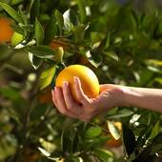

Change in Quantity Supplied: is a _________________ the supply curve showing a change in the quantity of the product supplied in response to a change in price. This is simply a restatement of the law of supply.

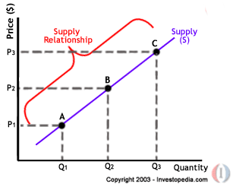

Change in Supply: when firms are now willing to offer different amounts of the product for sale at the same prices as before. This is shown as a _________ in the curve, not a movement along the curve.

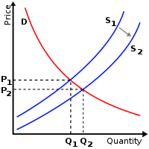

An increase in supply is a _________________.

A decrease in supply is a _________________.

There are 7 factors that can shift the supply curve to the right or left. These factors have nothing to do with the price of the product.

- Cost of Inputs: when a firm pays _______ for its land, labor or raw materials, it is willing to supply ________ now. The reason is that the firm is making more profits as their costs fall. If the cost of resources ____________, the firm will supply _______.

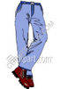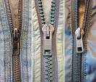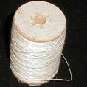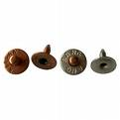

- Productivity: when workers are more efficient they can produce more. The result is that costs ______, so firms are willing to supply _______ than before. When workers are not as productive, costs rise and the firm is not as willing to supply.
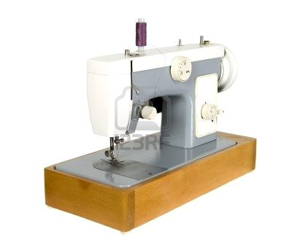

- Technology: the introduction of a new machine or process will ______ the firm’s ______ and will result in an ___________ in supply. Think about flat screen tv’s and computers. What has happened to their costs over the last several years?

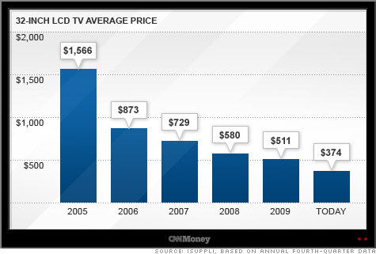

- Taxes: firms view taxes as an increase in their costs and therefore supply will fall. Taxes will always shift the supply curve to the ______.

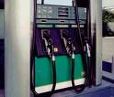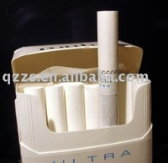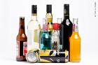

- Subsidies: are the opposite of a tax. In this case the government gives money to firms to encourage or protect a certain type of economic activity. Subsidies ________ costs and ___________ supply.

- Government Regulations: when the government regulates a firms product, costs _______ and supply _______. Ask yourself how much more expensive it is to comply with federal standards on exhaust emissions for cars. More regulation means _______ supply. Less regulation means ________ supply.

- Number of Sellers: more firms leads to more supply, fewer firms leads to less supply.

Supply elasticity is measured the same way as demand elasticity.

- Elastic Supply: when a given change in price causes a ________________ change in quantity supplied.
- Inelastic Supply: when a given change in price causes a _______________ change in quantity supplied.
- Unit Elastic Supply: when a given change in price causes a _____________ change in quantity supplied.

Price: is the monetary value of a product or service and is established by __________________.

Prices act as ___________ that help us make our economic decisions. Prices communicate information and provide incentives to buyers and sellers.

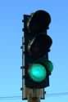

For example:

High Price—firms want to produce _______ but consumers want to buy _______.

Low Price—firms want to produce ______ but consumers want to buy ________.

How would society allocate goods/ services and resources without a system of prices? One possible method could be rationing.

Rationing: is a system under which an agency such as government decides everyone’s _____________.

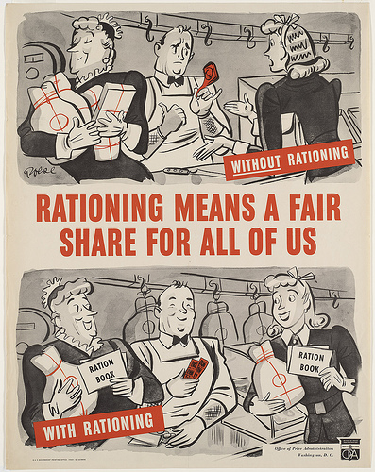

3 problems of rationing include:
- ____________

- _________________

- _______________________
Rebate: a partial _________ of the original price of the product.

We now want to bring supply and demand together to determine how prices are established in a market economy. It is a process of __________________.

Market Equilibrium: is a situation in which prices are relatively _________ and the quantity supplied is __________ the quantity demanded.

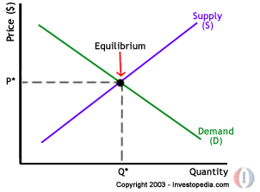

Surplus: when the quantity supplied is ________ than the quantity demanded at a given price. The result of the surplus is that price will _______. ( Qs $>$ Qd )

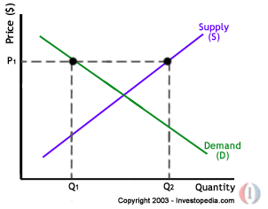

Shortage: when the quantity demanded is __________ than the quantity supplied at a given price. The result of a shortage is that price will ______, (Qd > Qs).

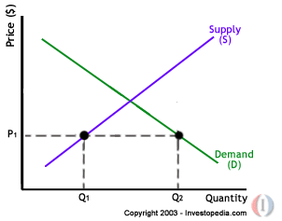

Equilibrium Price: the price that _______________ by leaving neither a surplus not a shortage, ( Qs = Qd).
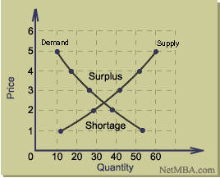

Sometimes society may have to sacrifice some __________________ in order to achieve greater ________________. Think back to the economic and social goals in unit 1.

One common way to achieve more equity or security for certain groups of people is for the government to ___________ at the socially desirable level. When this happens, prices are not allowed to adjust to reach equilibrium.

2 examples include price ceilings and price floors.

Price Ceiling: the ________________ that can be charged for a product. An example is rent control.
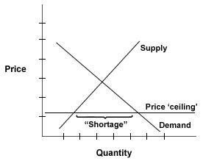

Price Floor: the ________________ that can be charged for a product. Examples include minimum wage and farm products.

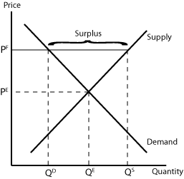

Legal forms of business shows the 3 main ways businesses are set up. Look at Chapter 8 in our textbook to see descriptions of business organizations.

- Sole Proprietorship: a business owned and operated by __________. It is the most common form of business numerically.
- Partnership: a business jointly owned by ______________. 2 types include;

- General- all partners are responsible for the management and financial obligations of the business.
- Limited- at least 1 partner is not active in the daily operation of the business although they may have contributed funds to help finance the operation.
- Corporation: is recognized by law as a separate legal entity having all the rights of an individual.

Important aspects of a corporation include:

Charter: a government document giving permission to create a corporation.
- Corporation’s name
- Its purpose
- Number of shares to be issued
- Names of parties who started it
Stock: ownership certificates in a corporation. Investors buy shares of stock in hopes of ______________ by selling the stock for more than they paid for them. This is called a capital gain.

Stockholders/Shareholders: are investors who buy shares of stock.

Dividends: a check representing a portion of the corporation’s profits paid back to the shareholders each quarter. This is another way investors make money in the stock market.

Profit Motive: this is the driving force that encourages people and organizations to improve their material well-being. Entrepreneurs start businesses to make the greatest amount of profit possible.

Total Revenue > Total Cost - ___________
Total Revenue < Total Cost - ___________
Total Revenue = Total Cost - ___________

Market Structure: represents the nature and degree of competition among firms operating in the same industry.

An industry represents all firms in the same market like airlines or cars.

We will examine 4 types of market structures by looking at their characteristics.

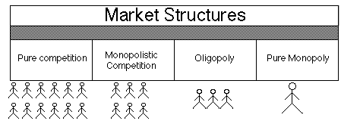

- Perfect Competition
- ______________ of buyers and sellers, 100’s to 1000’s.
- Each firm has __________ over price.
- Buyers and sellers deal in an _______________.
- Buyers and sellers are __________________ the market when they choose.
- ___________________.

- Monopolistic Competition
- ________ number of buyers and sellers, 20 to 70 firms.
- Have a ____________ over price.
- Buyers and sellers deal in a ____________________.
- Buyers and sellers are __________________ the market.
- There is __________________ by firms.

Examples include gas stations and drycleaners.

Product Differentiation: the real or imagined differences between competing products in the same industry. Examples of differentiation include;
- Store location
- Store design
- Manner of payment
- Delivery options
- Packaging
- Service
- Store merchandising

Non-price competition: the use of advertising, promotions or giveaways to convince buyers that their product is better than another brand.

- Oligopoly
- __________, 3 to 12.
- ____________ over price with collusion.
- The product can be _________ or ________________.
- It is _______________________________.
- There is ________________ by these firms.

Examples include airlines, automobiles and steel.

Interdependent Behavior: whenever one firm acts, it musdt consider how the other firms will respond.
Raise price- _________
Lower price- ________

Collusion: a formal agreement to set prices or behave in a _____________ manner to increase profits. A good example is OPEC. Collusion is illegal in the United States

Price-fixing: agreeing to charge the same or similar price for a product.

- Monopoly
- A ___________, 1.
- __________________ over price.
- The product is _________ with no close substitutes.
- It is ____________________ this market.
- ___________________ unless it is for public relations reasons.

The best examples are the local power company or water company.
Types of monopolies

- Natural Monopoly: when the costs of production are minimized by having a single firm produce the good. This is called ___________________.

- Geographic Monopoly: a single firm by virtue of its __________ such as a country store.

- Technological Monopoly: a monopoly based on the ownership or control of a manufacturing method, process or other specific advance such as a ________ or _____________.

- Government Monopoly: a monopoly that the government _______ and _______ like the postal service, the city water company or the TVA, the Tennessee Valley Authority.

Sometimes _____________ because of inadequate competition, inadequate information, resource immobility, externalities and public goods.

We will focus on 2 types of market failures.

- Externalities: a cost or benefit that accrues to a 3rd party not involved in the transaction. Take a look at the photo on pg 175.

Negative- noise, air or water pollution
Positive- education or immunizations

- Public Goods: goods or services that are _____________________ by everyone, and whose use by 1 person does not diminish the satisfaction or value available to others. Public goods are not excludable and non rival.

Excludability: refers to the idea that a person can be prevented from using a product they don’t pay for.

Rivalry: refers to the idea where one person’s use of a product will diminish other people’s use of the same product.

Free rider: refers to a person who receives the benefit of a good without paying for it.

Private goods Public goods
- 2.
3. 4.
5. 6.

The left column is _______ and ____________ while the right column is __________ and _______________.

